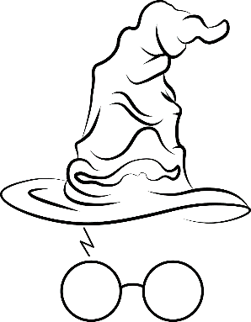  Gryffindor | Gryffindor | Gryffindor | Gryffindor
Slytherin | Slytherin | Slytherin | Slytherin
Hufflepuff | Hufflepuff | Hufflepuff | Hufflepuff
Ravenclaw | Ravenclaw | Ravenclaw | Ravenclaw

